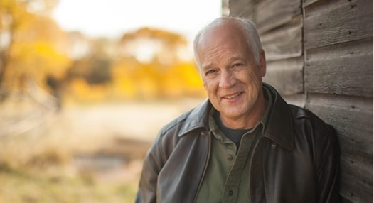[***Understanding Our Times & the Biblical Path Forward* In-Person with Dr. Del Tackett Saturday, November 2, 2024 Cheyenne,**](https://www.deltackett.com/events/understanding-our-times-the-biblical-path-forward-live-with-dr-tackett-oct-12-manhattan-ks) **WY**

**9 am to 12:30 pm**

**Teacher of *The Truth Project*, *Is Genesis History?*, *Engagement Project***

**and many Biblical worldview studies.**

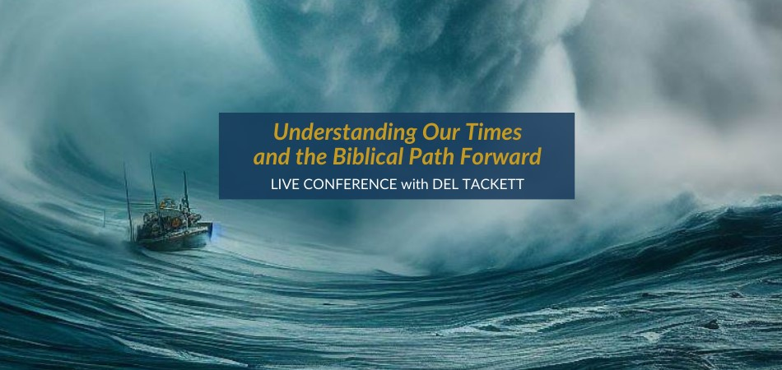

*“ And from Issachar, men who understood the times and knew what Israel should do…"*1 Chronicles 12:32

*Understanding Our Times and the Biblical Path Forward* is Dr. Tackett's most recent Biblical worldview conference. Drawn from a livestream series (*7 Threats in Our Culture*) and his latest video study (*The Engagement Project*).

**Dr. Tackett shows us from the Scripture what we are seeing play out in our culture today as we rapidly depart from Biblical foundations and exchange the Truth of God for a host of lies. We pray you will gain a deeper understanding of the primary battlegrounds in our culture: from the family to the church, work and government.** **We will seek to gaze upon the crown jewel in the nature of God and His vision for His people. We will contemplate what could well be the only Biblical way forward in our times—one that was followed for the first 200 years before we tragically set it aside.**

**Location: Cheyenne Hills Church, 7505 US Highway 30, Cheyenne, WY**

Join us for this special time as we seek to gain Biblical insight into the times in which we find ourselves, and therefore, like the sons of Issachar, understand what the people of God should do.

**Registration Options:**

* Individual for Understanding the Times Conference, $20
* Couple for Understanding the Times Conference, $30
* Add on *The Engagement Project*Small Group Materials (Streaming or Streaming and DVD set, If you would also like to purchase The Engagement Project Small Group Resources, you may do so at this time, with the materials handed to you at the time of the conference.

**Small Group Resource, Streaming Only**

* Individual for Understanding the Times Conference PLUS receive The Engagement Project Small Group Materials for hosting your own small group, Streaming Only (unlimited online access granted with no end date), $50
* Couple for Understanding the Times Conference PLUS receive The Engagement Project Small Group Materials for hosting your own small group, Streaming Only (unlimited online access granted with no end date), $60

**Small Group Resource, Streaming AND DVD Set**

* Individual for Understanding the Times Conference PLUS receive The Engagement Project Small Group Materials for hosting your own small group, Streaming AND DVD Set, $80
* Couple for Understanding the Times Conference PLUS receive The Engagement Project Small Group Materials for hosting your own small group, Streaming AND DVD Set, $90

**SATURDAY, NOVEMBER 2, 2024 - SCHEDULE**

8:30 AM - 9:00 AM Registration / Check-In

9:00 AM - 10:15 AM Session 1

10:15 AM - 10:30 AM Break

10:30 AM - 11:30 AM Session 2

11:30 AM - 11:45 AM Break

11:45 AM - 12:30 PM Session 3

**TO REGISTER:**

[www.deltackett.com/LIVE](http://www.deltackett.com/LIVE)

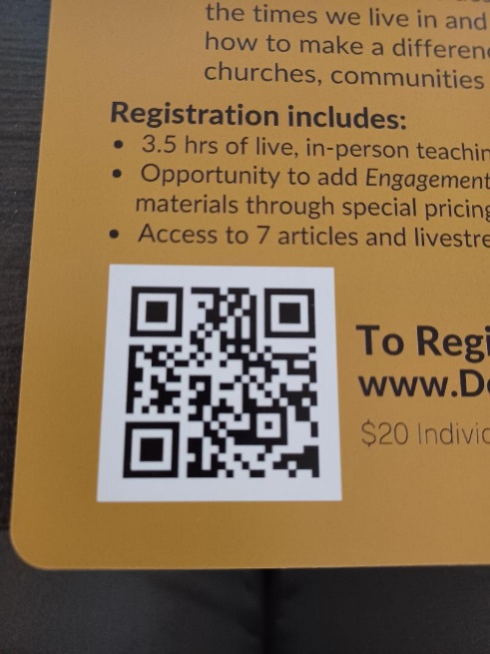

**Host name:** Truth Encounter Ministries

**Host contact email:** marc.fey@truthencounterministries.org

**EVENT LOCATION:**

**Cheyenne Hills Church**

**7505 US Highway 30  
Cheyenne, WY**